-- Final Exam MIS 443 Q4 - 2024-2025 - Skeleton

-- Your ID:

-- Your Name:

/*

Question 1 (10 marks): Create a database named “yourfullname” (e.g: dangthaidoan”) use PGAdmin, then create a schema name “cd” that has three tables: members, bookings and facilities

using SQL statements. Ensure each table includes appropriate primary and foreign keys, and data types.

Submit the SQL script as part of your answer.

*/

-- Q1.A Check tables

SELECT table_name, column_name, data_type

FROM information_schema.columns

WHERE table_schema = 'ba'

ORDER BY table_name, ordinal_position;

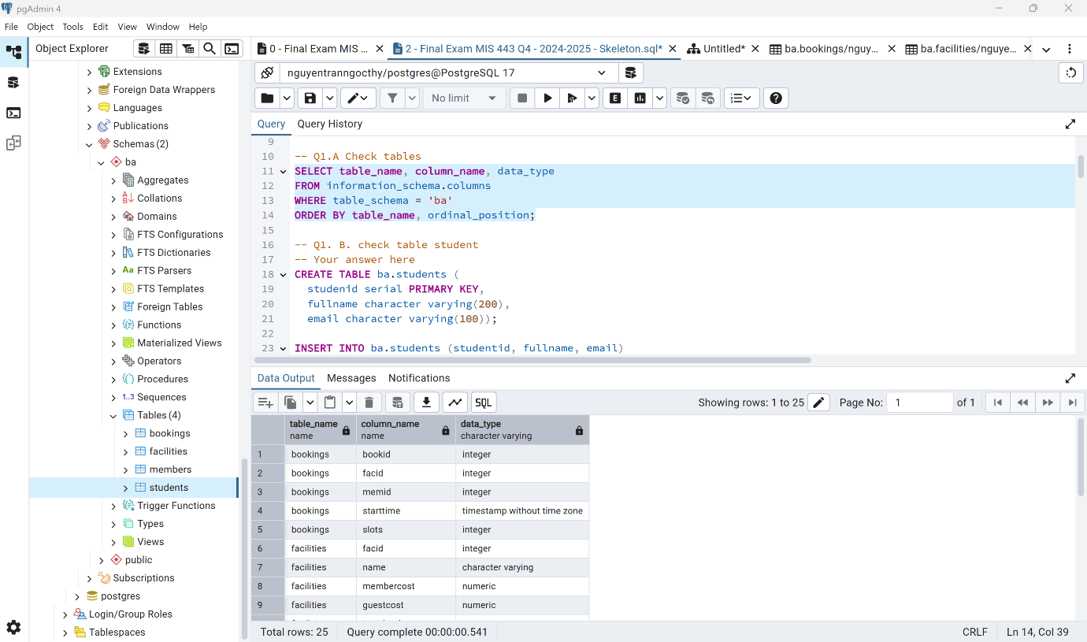

-- Q1. B. check table student

-- Your answer here

select column_name, data_type

from information_schema.columns

where table_schema = 'ba' and table_name = 'students'

order by ordinal_position;

select * from ba.students order by created_at desc;

CREATE TABLE ba.students (

studenid serial PRIMARY KEY,

fullname character varying(200),

email character varying(100));

INSERT INTO ba.students (studentid, fullname, email)

VALUES ('2232300307', 'Nguyen Tran Ngoc Thy', 'thy.nguyentran.bbs22@eiu.edu.vn');

-- End your answer

/*

Question 2 (10 marks): Write an SQL query to find the top 3 facilities that have been booked the most number of total slots (not just number of bookings).

Display their facility ID and the total number of slots booked, sorted from highest to lowest.

*/

-- Your answer here

select b.facid, sum(b.slots) as total_slots

from ba.bookings as b

group by b.facid

order by total_slots desc

limit 3;

-- End your answer

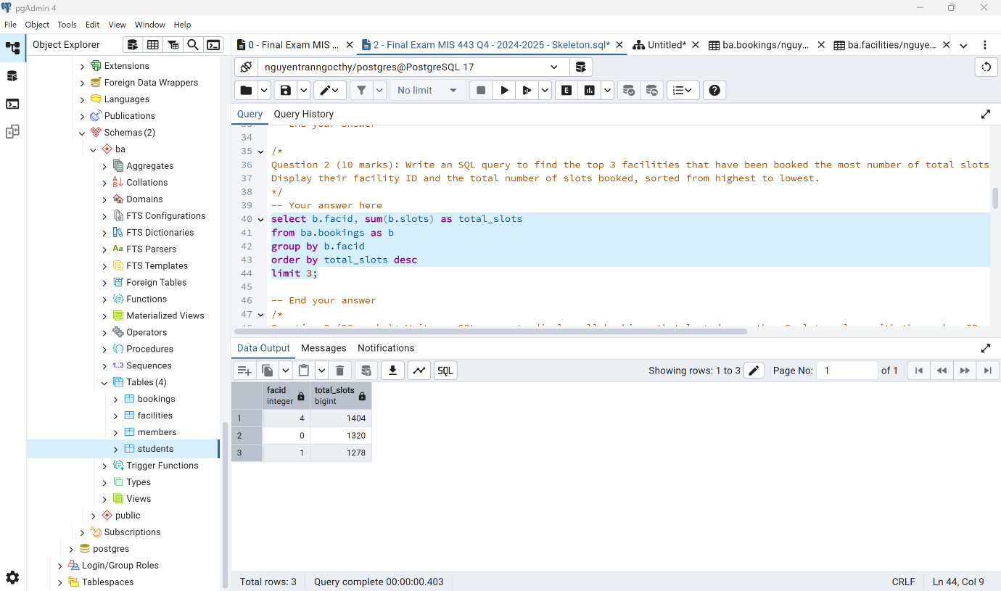

Question 3 (20 marks): Write an SQL query to display all bookings that lasted more than 2 slots, along with the member ID, facility ID, and facility name,

sorted by member ID and then by start time (ascending).

-- Your answer here

select b.memid, b.facid, f.name as facility_name, b.starttime, b.slots

from ba.bookings as b

join ba.facilities as f on f.facid = b.facid

where b.slots > 2

order by b.memid, b.starttime;

-- End your answer

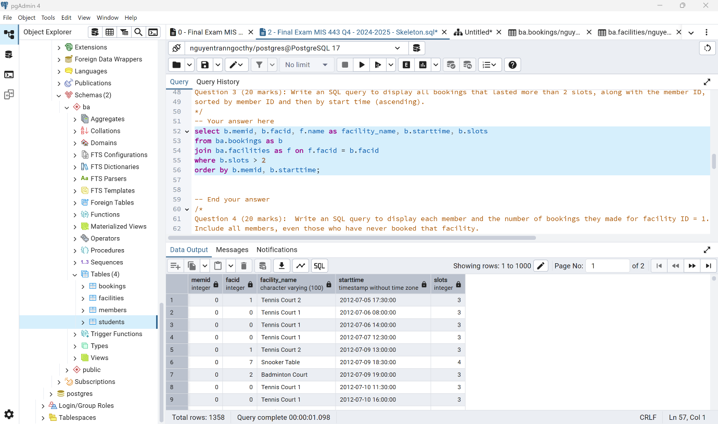

Question 4 (20 marks): Write an SQL query to display each member and the number of bookings they made for facility ID = 1.

Include all members, even those who have never booked that facility.

-- Your answer here

select m.memid, m.firstname ||' '|| m.surname as member_name,

coalesce(count(b.bookid), 0) as facility1_bookings

from ba.members as m

left join ba.bookings as b on b.memid = m.memid

and b.facid = 1

group by m.memid

order by facility1_bookings desc;

-- End your answer

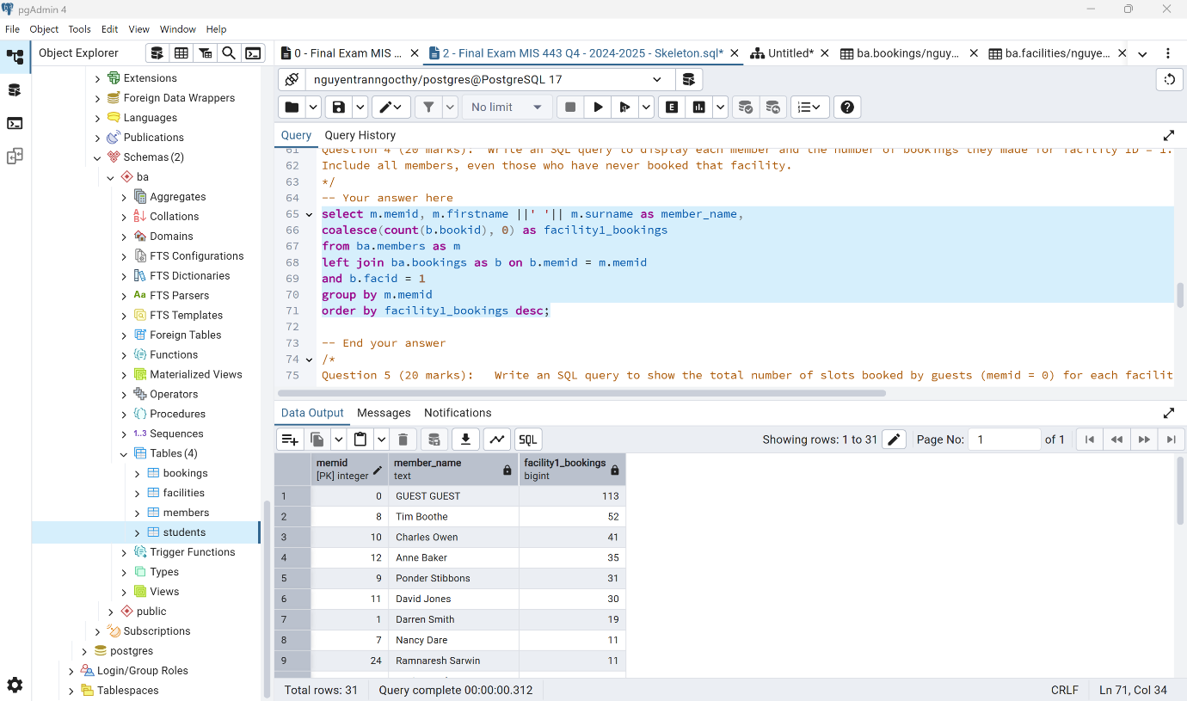

Question 5 (20 marks): Write an SQL query to show the total number of slots booked by guests (memid = 0) for each facility.

Include the facility name and display the result in descending order of total slots used.

-- Your answer here

select f.facid, f.name as facility_name,

coalesce(sum(case when b.memid=0 then b.slots end), 0) as total_guest_slots

from ba.facilities f

left join ba.bookings as b on b.facid = f.facid

group by f.facid, f.name

order by total_guest_slots desc, f.facid;

-- End your answer

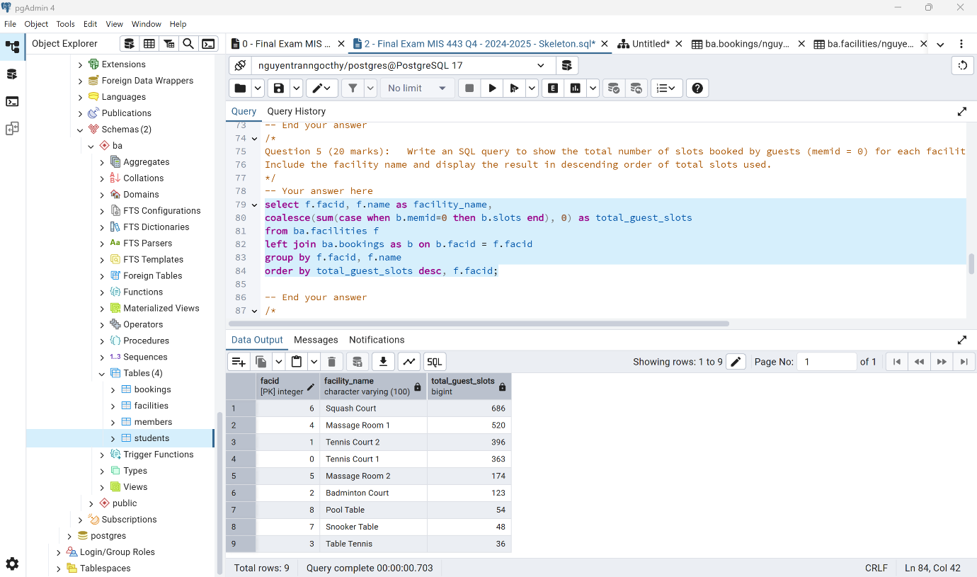

Question 6 (20 marks): Write an SQL query to rank members based on their total number of bookings.

Members with the same number of bookings should have the same rank. Only include members who have made at least one booking

-- Your answer here

with cnt as (

select b.memid,

count(*) as total_bookings

from cd.bookings as b

where b.memid <> 0 -- loại guest

group by b.memid

)

select m.memid,

m.firstname || ' ' || m.surname as member_name,

c.total_bookings,

rank() over (order by c.total_bookings desc) as rnk

from cnt as c

join cd.members as m on m.memid = c.memid

order by rnk, m.memid;

Output:

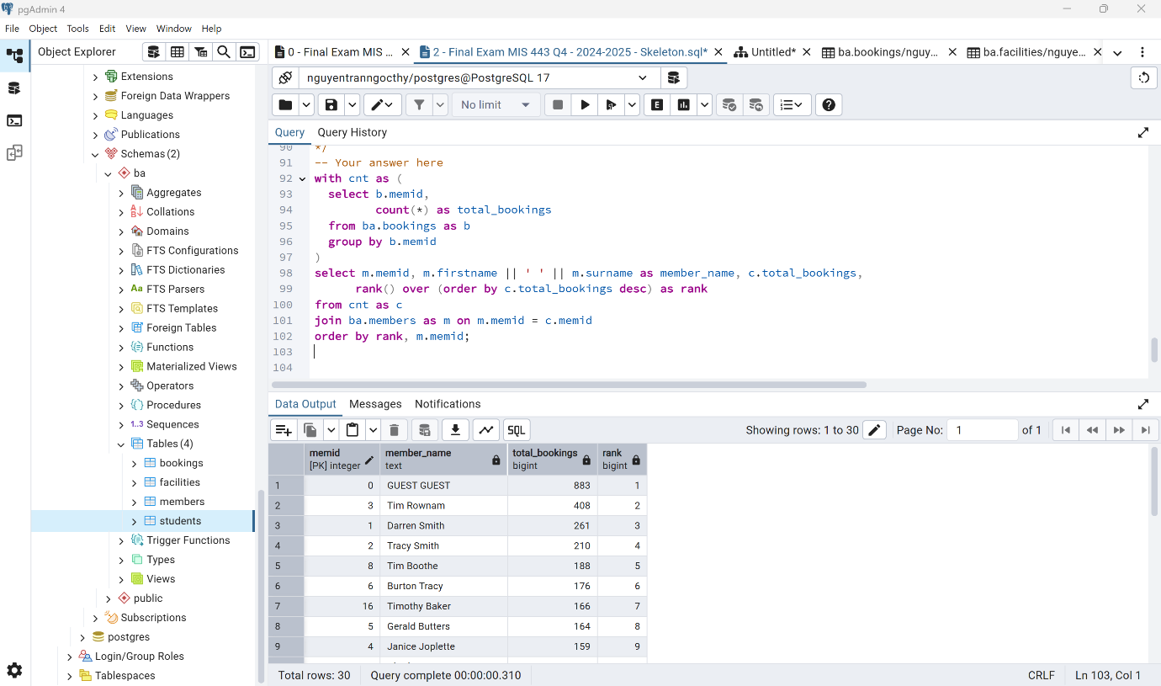

Link GitHub: https://github.com/thynguyen1120/MIS443